Press system for thick-walled steel pipes delivers time savings of as much as 80 percent compared to welding

Megapress XL from Viega connects steel pipes up to 4 inches size in seconds

Frankfurt/Attendorn, 14 March 2017 – With its Megapress piping system, Viega enables pressing of thick-walled steel pipes in sizes from ⅜ of an inch to 2 inches. Thanks to the new XL connectors, Megapress can now also be used in large-scale installations. Viega has additionally developed the Pressgun press booster to work in conjunction with the connectors. As a result, even the new 2½, 3 and 4 inch sizes can be pressed in seconds.

Installations comprising thick-walled steel pipes to DIN EN 10255, DIN EN 10220/10216-1 and DIN EN 10220/10217-1 are often still welded, and in some cases bolted or joined by couplings. Thanks to Viega, cold press connecting technology is now establishing itself in those applications too. With the Megapress piping system, thick-walled steel pipes with rough surfaces up to 2 inches can be pressed with ease. With no open flame, and so no fire risk, a safe, reliably leak-tight pipe connection is created in just a few seconds, and can be immediately subjected to full loading. With the addition to the system of the Megapress XL, those processing advantages now also apply for thick-walled steel pipes in 2½, 3 and 4 inch sizes.

Pressing up to 80 percent faster than welding

With the Megapress XL connectors, the pressing is carried out using a so-called press booster, tailored to the specific system, which can be driven by any Viega press machine from Type 2 up to and including Pressgun 5. With this specially developed press force booster, even the new XL connectors can be pressed in a matter of seconds. Depending on size, time savings are as much as 80 percent compared to welding.

Its light weight, carrying strap and ergonomically styled handle make the Pressgun press booster safe and easy to use. It makes pipe installations up to and including 4 inch size much easier, even when working at height and in tight spaces.

Extensive range with the "SC-Contur" quality advantage

Megapress XL connectors are made of steel and coated with zinc-nickel. The sealing element is made of FKM, and is rated for operating temperatures up to 140 °C. An extensive range of sleeves, elbows, adapters, reducers, T-pieces and flanges provide solutions for virtually any installation.

Like all Viega press connectors, the new Megapress XL connectors feature the "SC-Contur". This designed-in leakiness in the unpressed state ensures that any mistakenly unpressed connectors are immediately detected in the leakage test. After pressing the connection is permanently leak-tight.

The Megapress XL range has acquired a number of key approvals right from market launch: VdS approval for sprinkler systems; TÜV approval for compressed air and heating systems; and approvals from DNV/GL, LR and RINA for shipbuilding.

EN_PR_170314_MegapressXL.docx

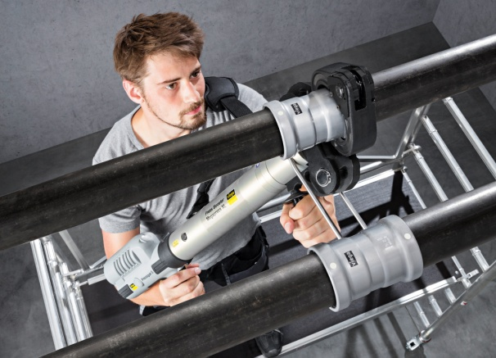

PR_170314_MegapressXL_01.jpg
Thick-walled steel pipes from 2½ to 4 inches in size can now be pressed with ease using Megapress XL and the Pressgun press booster from Viega. This delivers time savings of as much as 80 percent compared to conventional welding. (Photos: Viega)
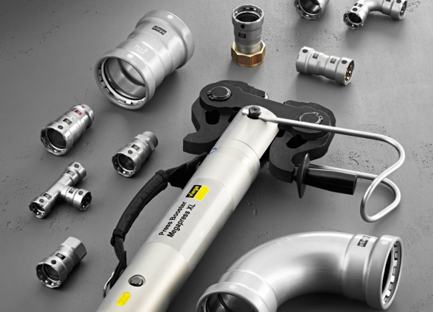

PR_170314_MegapressXL_02.jpg
Megapress XL rounds off the top end of the Viega range of press connectors for thick-walled steel pipes. (Photo: Viega)

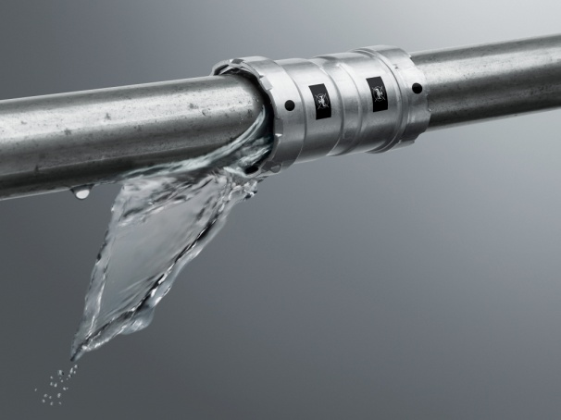

PR_170314_MegapressXL_03.jpg
The quality attributes of all Viega press connectors are also embodied in the Megapress XL piping system: The "SC-Contur" reveals any mistakenly unpressed connectors during the leakage test at the latest. (Photo: Viega)

About the company:
Worldwide, more than 4,000 people are employed by the Viega Group, which is among the leading manufacturers of installation technology for sanitary and heating systems. Viega is working to continue its long-term success at nine locations. While production is concentrated at its four main sites in Germany, the McPherson/USA group manufactures solutions specially designed for the North American market. And the Wuxi/China site focuses on production for the Asian market. Installation technology as a core skill drives growth forward. Pre-wall and drainage technology belong to the product range alongside piping systems. The range consists of approximately 17,000 articles, which are used nearly everywhere: in building services installations, in utilities or in industrial plant construction and shipbuilding.
The family-owned business was founded in Attendorn, Germany, in 1899. In the 1960s, the course was set for the internationalisation of the group. Viega brand products are used all over the world. Distribution mainly takes place via sales and marketing organisations in the respective countries.

